COUNT
SELECT COUNT (EMP_ID) FROM EMPLOYEES;
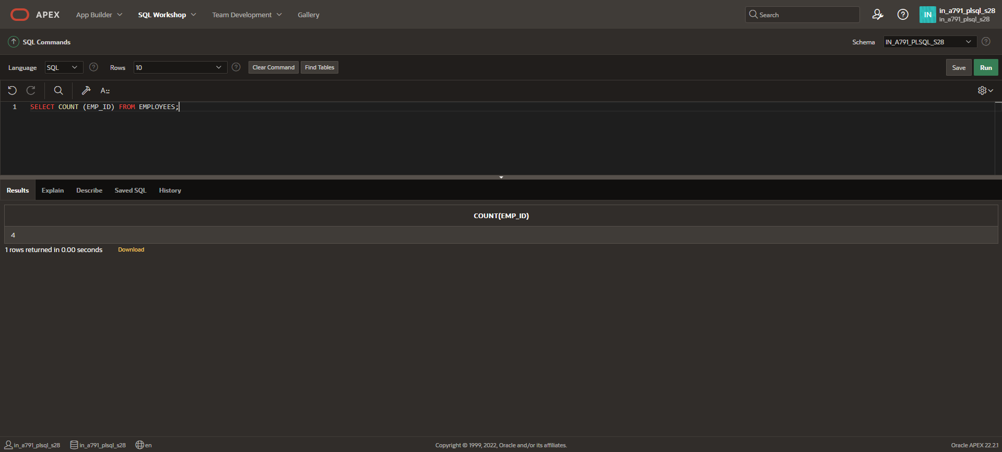
COUNT ALL ROWS
SELECT COUNT(*) FROM EMPLOYEES WHERE EMP_ID<5;
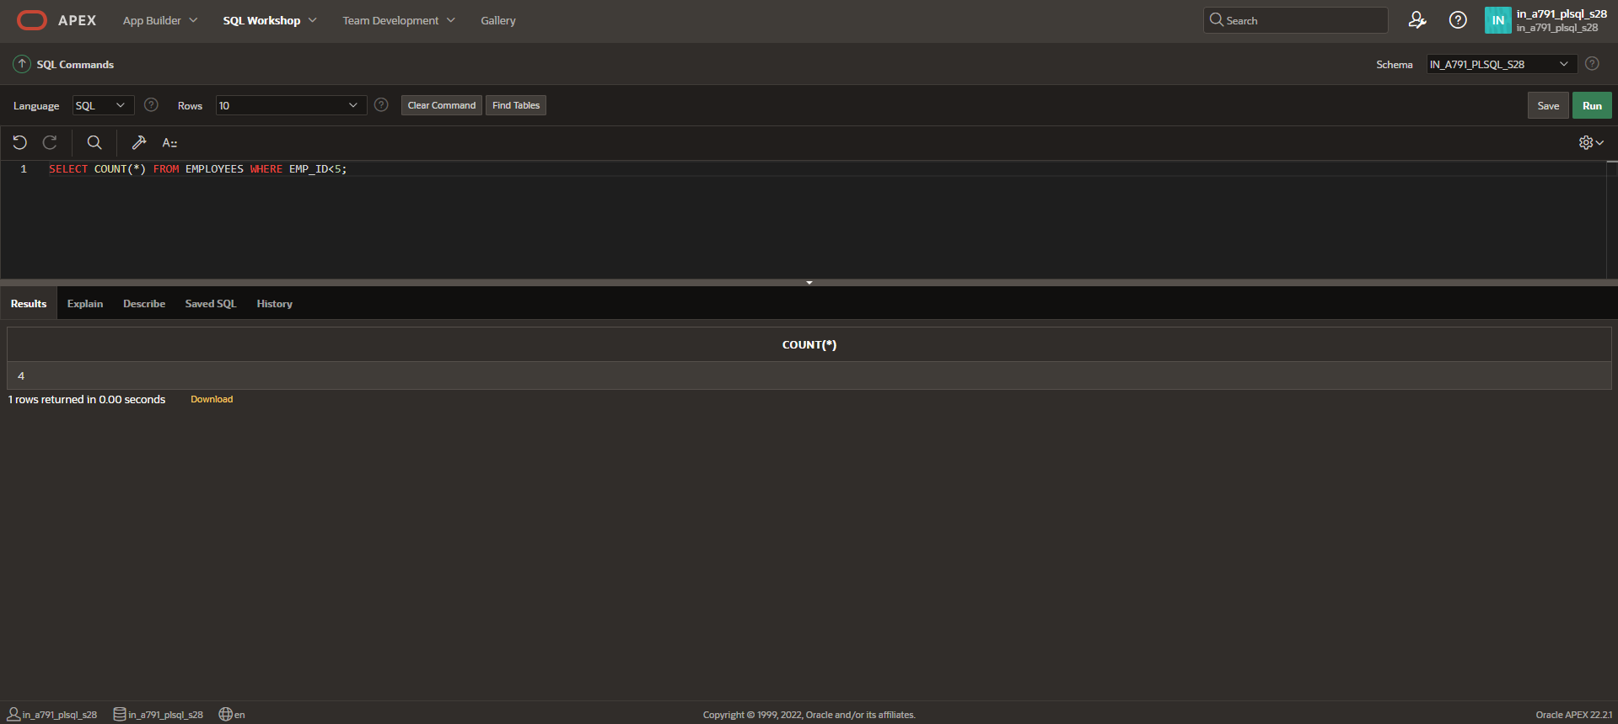

DISTINCT AND COUNT
SELECT COUNT (DISTINCT EMP_NAME) FROM EMPLOYEES;
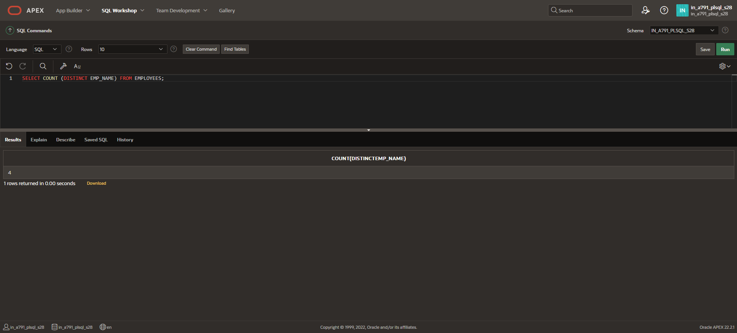
DISTINCT
SELECT DISTINCT DEP_ID FROM EMPLOYEES;
